Normalization

Consider a sample report layout of a report in a company.

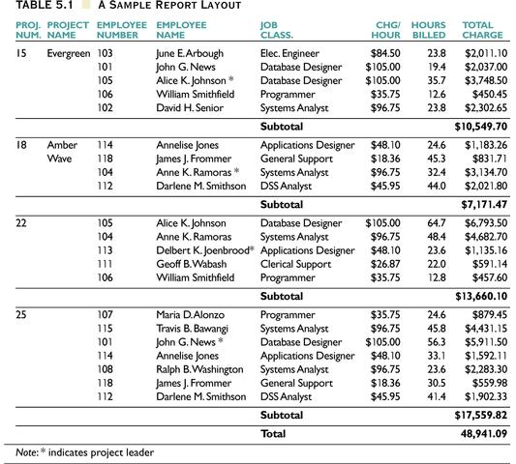
Identify what all attributes are required in one big table.
Example : Proj_num, Emp_num, ……
Think of this as the baseline – one large table.
Normalize the above table and decompose the above relations such that the decomposition is lossless join decomposition and ensure that those relations satisfy 1 NF, 2NF and 3 NF. Check if BCNF normal form is possible here.
Take a possible sample report pertaining to your assigned project. Perform normalization procedure as given in Q.1

